***PAAREES PERFUMES***

***DAVIDOFF***

***FOR MEN***

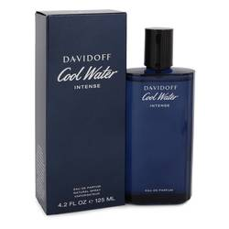

***Cool Water Intense***

***Description:***

Cool Water Intense by Davidoff Cologne. Cool Water Intense is the latest offshoot of Cool Water, one of the most successful colognes ever. Nose Annick Menardo created Intense, which was launched in 2019. This refreshing citrus scent begins with a top note of green mandarin. The coconut nectar in the heart of the fragrance gives the cologne a tropical feel. It finishes off with a base note of amber.  
  
Zino Davidoff epitomized style and positivity, and he brought those qualities into his family business. He was inspired by his travels all around the world, where he searched for top-notch ingredients. Thanks to his efforts, his company is known for its luxurious, well-crafted products. The brand entered the fragrance industry in 1984 and launched Cool Water four years later. Besides Intense, Cool Water has inspired numerous other scents, including Cool Water Woman and Cool Water Woman Sensual Essence. The company is also known for its sophisticated eyewear, watches, leather goods and cognac.